Enhancing Sleep Tracking with Cough and Snore Recognition Using Edge Impulse Studio for Improved Respiratory Health Monitoring

Deepika Rani Sona¹, Rashmi Ranjan Das^{2*}, Leela Praneeth Puli ³, Mekala Manikanta^{4,} Kakarla Akash Gangireddy ^{5,} Swaroop Dintakurthi ⁶ , Santhosh Kumar Reddy ⁷
^{1,3,4,5,6,7}School of Electronics Engineering, Vellore Institute of Technology, Vellore, India.
²School of Electrical Engineering, Vellore Institute of Technology, Vellore, India.
* Corresponding Author.
Email Address: rashmiranjandas@vit.ac.in (Rashmi Ranjan Das)
Corresponding author's ORCID profile:
https://orcid.org/0000-0001-7629-0815

Abstract - This paper presents a novel method for cough and snore recognition in sleep tracking using Edge Impulse Studio. Sleep tracking is important for monitoring overall health and identifying potential sleep disorders. However, current sleep tracking methods do not typically recognize coughing and snoring, which can be important indicators of respiratory problems. The proposed approach uses Edge Impulse Studio, an end-to-end development platform for embedded machine learning, to train a machine learning model to recognize coughs and snores in audio data collected during sleep. The results show that the model achieves high accuracy of 93.1% in recognizing coughs and snores, which can improve sleep tracking accuracy and help identify potential respiratory problems in individuals. The proposed approach has the potential to be implemented in wearable devices and smart home technology, enabling individuals to monitor their sleep health in a non-invasive and efficient manner.
Keywords - Edge Impulse Studio, Sleep Tracking, Sleep Health, Cough recognition, Snore recognition, Audio classification.

1. Introduction
Sleep is a fundamental aspect of our overall health and well-being, yet it is often overlooked. During sleep, our bodies undergo important restorative processes, and the movements, sounds, and patterns of our sleep can reveal important insights into our respiratory health, stress levels, and other important metrics. However, traditional sleep tracking methods often require wearable devices, which can be uncomfortable and disruptive to sleep. With the help of IoT and machine learning concepts, we can create a comprehensive sleep tracking environment that can track, measure, and store the data it collects from sensors such as photoresistors, IR sensors, and microphones in the cloud. By leveraging machine learning algorithms, we can analyze this data and gain valuable insights into our sleep patterns, including the occurrence of coughing and snoring. In addition to using Edge Impulse Studio, we also leveraged Kaggle to access the Google AudioSet Dataset. Kaggle is a platform that hosts various datasets and challenges related to data science and machine learning. Kaggle provided us with a convenient way to access this dataset, as it includes preprocessed audio files that can be directly used in our project. This allowed us to quickly obtain the necessary data for training our machine learning model without the need for additional preprocessing steps. This work aims to develop an unobtrusive tableside system that can track and monitor sleep with minimal input and effort from the user. Using Edge Impulse Studio, an end-to-end development platform for embedded machine learning, we can train a model to recognize coughs and snores in audio data collected during sleep. This approach has the potential to significantly improve the accuracy of sleep tracking and help individuals identify potential respiratory problems.
Overall, the proposed system offers a non-invasive and efficient way to monitor sleep health and make any necessary changes to sleep habits, allowing individuals to start their day in the best way possible. By circumventing the need for uncomfortable wearable devices, this system has the potential to significantly improve the user experience of sleep tracking and enable individuals to achieve better overall health outcomes.

2. Literature Survey

The literature on sleep monitoring and respiratory sound analysis showcases a diverse array of research efforts, each contributing to the evolving landscape of this field. Smartphone-based system laid the groundwork for detailed sleep tracking, introducing the concept of using earphones to record acoustic sounds and incorporating accelerometer data for improved sleep event identification [1]. Automated diagnosis support for sleep problems, evaluating different datasets and signals, particularly focusing on sleep disorders like apnea and insomnia [2]. In parallel snore classification is addressed using spectral entropy and Convolutional Neural Network (CNN), emphasizing the effectiveness of Mel spectrograms and a combined CNN and DNN approach for snore detection [3]. Differentiating normal snorers and patients with Sleep Apnea and Hypopnea Syndrome (SAHS), researchers highlighting the significance of analyzing snoring characteristics before and after treatment [4]. Automated snore analysis system further advanced the field, introducing a new algorithm for OSA screening and exploring factors like sleep position and stage in snore demographics [5]. Snoring identification and extraction is explored using tracheal and ambient microphones, demonstrating variations in accuracy between the two [6]. Replacing PSG is proposed with pressure-sensitive mats for detecting central sleep apneas, utilizing deep learning techniques for automatic detection [7]. Use of embedded system to observed and inferred sleeping patterns using a multi-layered approach, emphasizing the importance of comprehensive monitoring [8]. A learning model for snore detection using a smartphone showcased the optimization of models for mobile devices, specifically employing CNN for Android-based snore detection [9], [10]. Study applied machine learning to public and nuclear safety, using the Edge Impulse platform for detecting and classifying different Gamma radiations. In the realm of sleep phases, investigated the sound localization capability of the brain during NREM sleep, analyzing MRI and MEG data [11]. The importance of sleep tracking is emphasized using sensors between the mattress and frame, introducing an algorithm for empirical data on sleep quality [12]. Body modeling applications are explored, using algorithms to recognize and imitate complex body poses in image sequences. Deep Neural Network for self-driving cars, outperforming existing methods in safety metrics [13],[14]. Spirometer-based cough detection method is introduced for increased accuracy, employing an artificial neural network for airflow signal analysis [15]. Shortcomings in contemporary speech recognition models, proposing a dual-input model using audio and video cues for improved accuracy during NREM sleep [16].
Smartphones' ability is evaluated to record cough events and snore duration, employing an energy threshold approach and a k-NN classifier [17]. Advanced automated methods for detecting coughs and snores, exploring generalized, semi-personalized, and personalized approaches are mentioned [18]. Healthcare experts struggle to accurately diagnose cough characteristics, highlighting the need for new techniques. The challenges of objectively quantifying coughs are discussed using recorded sounds and suggested the need for automated ambulatory systems [19], [20]. Respiratory physicians’ consistency is investigated in counting cough sounds, evaluating cough counts across different methods and listeners. Portable microcontroller-based device for home monitoring of snoring is presented in [21],[22]. Google's entry into sleep tracking technology is observed, allowing users to track snore and cough during sleep through the Pixel lineup [23]. The significance of paying attention to the sound of a cough in patients with COPD was highlighted in [24]. Regular monitoring of coughing in COPD patients is recommended, criticizing the outdated method of tracking patient coughing. The research emphasized the importance of early detection of COVID-19 and other flu-related illnesses [25-26].

2.1 Problem formulation and research contributions

The main issue we are tackling in this research is the improvement of sleep monitoring systems to offer a more accurate and holistic understanding of individuals' sleep quality and respiratory health. Conventional methods often struggle to effectively track subtle respiratory events like coughs and snores, which can be early signs of health problems. Additionally, methods like Polysomnography (PSG) as seen in [7] are uncomfortable for users. The challenge is creating a noninvasive system that combines tracking coughs and snores, using advanced data sets and training methods for better accuracy and user convenience.
- The research's key contribution is combining the tracking of coughs and snores in a single sleep monitoring system. This approach offers a more complete picture of sleep quality and potential health issues, allowing for a comprehensive assessment of respiratory health during sleep.
- The focus is on overcoming the drawbacks of invasive methods like PSG. Using non-intrusive techniques, such as acoustic sensing through smartphones or wearables, the proposed system ensures user comfort and makes long-term monitoring more feasible. This addresses a crucial limitation in traditional sleep monitoring, making it more widely acceptable.
- The research underscores the importance of using better data sets to train the monitoring system. Enhanced datasets, possibly incorporating diverse demographic information and a range of sleep conditions, contribute to a more robust and widely applicable model. Additionally, carefully considering training constraints aims to make the system more efficient while keeping computational demands in check.

By integrating cough and snore tracking, adopting non-intrusive monitoring, and optimizing data sets with suitable training methods, the research seeks to advance the capabilities of sleep monitoring systems. These contributions collectively work towards creating a more user-friendly, accurate, and widely applicable solution for evaluating sleep quality and respiratory health.

3. Methodology
Training a model to detect snoring and coughing using Edge Impulse Studio involves several steps. First, the user creates an account and a new project in Edge Impulse Studio. Next, the user uploads the audio data for snoring and coughing sounds and labels them accordingly. The data is then processed using Edge Impulse Studio's built-in data processing pipeline, which includes selecting appropriate sensor data, preprocessing the data, and converting it into an arrangement or design that can be used by the machine learning algorithm. Figure 1 shows block diagram for the recognition algorithm.

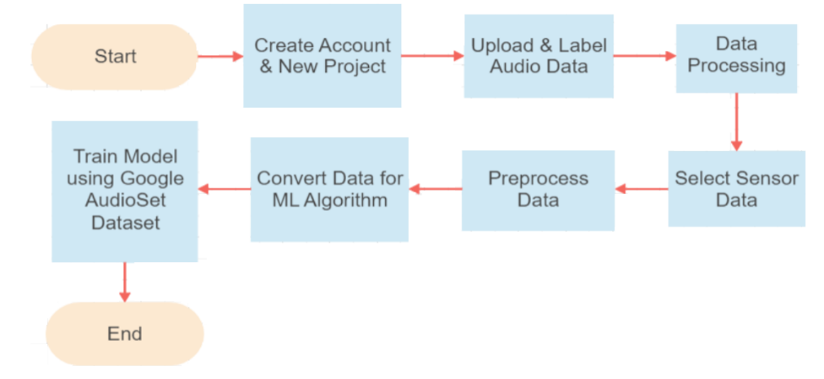
Fig. 1. System Block Diagram for the recognition algorithm

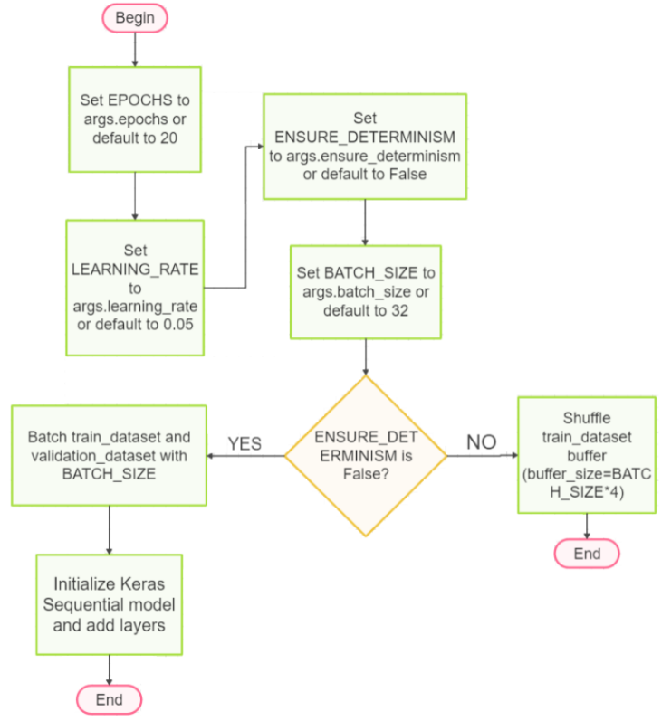
Fig.2. Flow diagram of the proposed system
For this investigation, we used the Google AudioSet Dataset for both coughing and snoring. The dataset contains over 200,000 audio segments of different sounds, including cough and snore. We then selected the appropriate audio segments for coughing and snoring and used them to train the machine-learning model. Edge Impulse Studio supports a variety of machine learning algorithms, such as neural networks, decision trees, and support vector machines. For this project, we used a neural network, specifically the Keras neural network, which is a widely used machine learning library for deep learning. Figure 2 illustrates the proposed systems flow diagram. All the steps involved here is to target the completion of the task effectively.
Once the model is trained, it can be used to detect snoring and coughing sounds in audio recordings. The accuracy of the model was improved by increasing the amount and diversity of the data, optimizing the preprocessing techniques, and fine-tuning the hyperparameters of the machine learning algorithm.
This model could be used in sleep studies to identify patients with sleep disorders and help improve their overall health and wellbeing. By detecting snoring and coughing sounds during sleep, this model can provide valuable insights into respiratory health and identify potential health risks.

3.1 Algorithm for the proposed keras scheme:
Inputs:
- args.epochs: Number of training epochs
- args.learning_rate: Learning rate for the optimizer
- args.ensure_determinism: Flag for ensuring determinism during training
- args.batch_size: Batch size for training
- train_dataset: TensorFlow Dataset for training
- validation_dataset: TensorFlow Dataset for validation
Outputs:
- model after post-training quantization
Begin:
1. Set EPOCHS to args.epochs or default to 20
2. Set LEARNING_RATE to args.learning_rate or default to 0.05
3. Set ENSURE_DETERMINISM to args.ensure_determinism or default to False
4. Set BATCH_SIZE to args.batch_size or default to 32
5. If ENSURE_DETERMINISM is False:
- Shuffle train_dataset buffer (buffer_size=BATCH_SIZE*4)
6. Batch train_dataset and validation_dataset with BATCH_SIZE
7. Initialize Keras Sequential model:
- Add Conv2D layer with 8 filters, kernel size 3, and ReLU activation
- Add Dropout layer with dropout rate 0.5
- Add Conv2D layer with 16 filters, kernel size 3, and ReLU activation
- Add Dropout layer with dropout rate 0.5
- Add Flatten layer
- Add Dense layer with classes units and Softmax activation
8. Initialize Adam optimizer with learning rate LEARNING_RATE
9. Initialize BatchLoggerCallback for logging training progress
10. Compile Keras model:
- Use 'categorical_crossentropy' as loss
- Use Adam optimizer
- Track 'accuracy' as a metric
11. Train Keras model:
- Use train_dataset for training
- Specify EPOCHS, validation data, verbosity, and callbacks
12. Define function akida_quantize_model(model, ...):
- Import cnn2snn module
- Quantize model using cnn2snn.quantize function
- Return quantized Akida model
13. Define function akida_perform_qat(akida_model, ...):
- Initialize EarlyStopping callback for monitoring 'val_accuracy'
- Add EarlyStopping callback to the provided callbacks list
- Compile Akida model with specified optimizer, loss, and metrics
- Train Akida model with train_dataset and validation_dataset
- Return trained Akida model
14. Call akida_quantize_model to quantize the Keras model
15. Call akida_perform_qat to perform quantization-aware training on the Akida model
End.
3.2. MFCC Feature Extraction in Preprocessing

Mel-Frequency Cepstral Coefficients (MFCCs) are a popular feature extraction technique used in speech and audio signal processing. MFCCs capture the essential characteristics of the spectral envelope of a signal and are commonly employed in speech and speaker recognition systems.
3.2.1. Pre-emphasis
Before computing the MFCCs, we apply pre-emphasis to the audio signal. This is done to amplify the high-frequency components that might have been attenuated during the recording process. The pre-emphasis operation is given by:
$y\left[n\right]=x\left[n\right]-α⋅x\left[n-1\right]$ (1)
    - Framing
We divide the pre-emphasized signal into short overlapping frames.

    - Windowing
Each frame is multiplied by a window function, often a Hamming window, to reduce spectral leakage:

$xi'​[n]=xi​[n]⋅w[n]$ (2)

    - Fast Fourier Transform (FFT)
We then apply the FFT to each windowed frame to obtain the power spectrum:

$Xi​[k]=FFT(xi'​[n])$ (3)

    - Mel Filterbank

$Si​\left[m\right]=∑k=0N-1​Hm​\left[k\right]⋅∣Xi​\left[k\right]∣2$ (4)

3.2.6. Logarithm
We take the logarithm of the mel-filterbank energies to mimic the logarithmic perception of loudness by the human auditory system:

$Ci​[m]=log(Si​[m])$ (5)

3.2.7. Discrete Cosine Transform (DCT)
Finally, we apply the DCT to the log mel-filterbank energies to decorrelate the coefficients and capture the cepstral information:

$MFCCi​\left[l\right]=∑m=1M​Ci​\left[m\right]⋅cos\left(2Mπl\left(2m-1\right)​\right)$ (6)

3.3 Keras Library

Microsoft Cognitive Toolkit (CNTK), TensorFlow, Theano, and other well-known deep learning frameworks may all be used with Keras, a high-level neural networks API built in Python. It offers a simple-to-use interface for deep learning model creation, training, and implementation. Keras abstracts away many of the complexities involved in building neural networks, making it accessible to users with varying levels of expertise.
This library allows for us to add different layers like the following:
3.3.1 Conv1D Layer

The Conv1D layer is used for one-dimensional convolutional operations. It is particularly effective for processing sequences, such as time series data or natural language processing (NLP) sequences.
The output of a Conv1D layer is computed using the convolution operation:

$output\left[i\right]=\sum{\begin{aligned}k=-1 \\ k=0\end{aligned}}​kernel\left[k\right]⋅input\left[i+k\right]+bias$ (7)

3.3.2 MaxPooling1D Layer

The MaxPooling1D layer is used to down-sample the spatial dimensions of the input, reducing its size and computational complexity.
The output of a MaxPooling1D layer is computed by taking the maximum value within a fixed window (pool size):

$output\left[i\right]=max\left(input\left[i×pool size:\left(i+1\right)×pool size\right]\right)$ (8)

3.3.3. Flatten Layer

The input is flattened, turning it from a multi-dimensional tensor into a one-dimensional vector, using the Flatten layer. This is often used as a bridge between convolutional layers and fully connected layers.
3.3.4. Dropout Layer
A regularization method called the Dropout layer works by randomly setting a portion of the input units to zero during training, therefore preventing overfitting.

4. Results and Discussions
After using various features from the EDGE impulse Studio, we developed separate models for cough in figure 3(a) and snore in figure 4(a) to maintain accuracy in both of them. After the model was trained using a multilevel neural network, each layer used a separate machine learning algorithm, and processes like smoothening and flattening of the features were used to get a model that was ready to be deployed in the real world. Here we can see the models, features, and the various Keras library methods used to train test and deploy the model in figure 3(b) and 4(b).

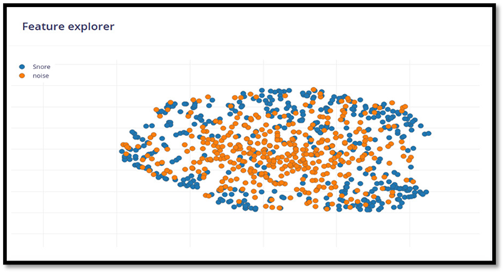

Fig. 3. (a) Generated features for snore

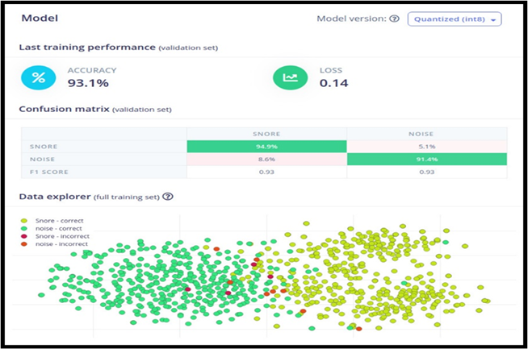

Fig. 3. (b) The model performance for snore

The cough model being a little less accurate is due to the limitation of the dataset. The datasets available to us, without help from any major medical institutes, are lackluster. They have a wider pool of noise and a narrower window of acceptable cough audio. But still, we can see from the Confucian matrix that our correct classifications occur way more than the mis-classification. This can be improved, if a major drive is done to collect natural cough audio without extra caveats for Covid or Pneumonia. Table I shows the data used to train the proposed work's snore model.

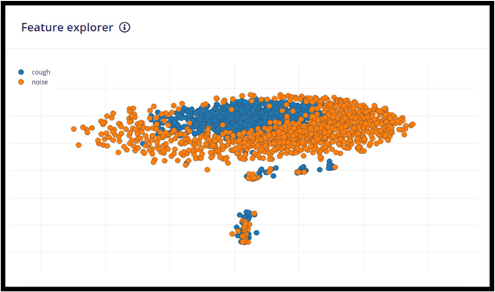

Fig. 4. (a) Generated features for cough

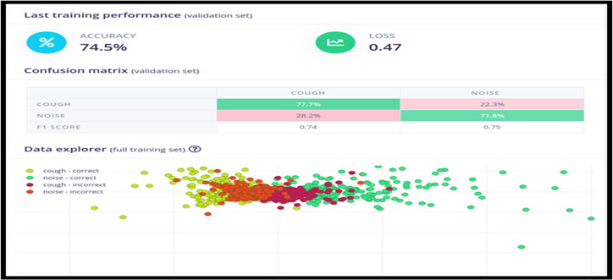

Fig. 4. (b) The model performance for cough

Table 1. Data used in training the snore model

Model | Total number of features | Accuracy in percentage
Using Edge Impulse studio and MFCC | 200 | 93.1%
Without using Edge Impulse studio and using WTCC | 26 | 93.57%

The more features contribute to better understanding of different snore audios and a more diverse recognition potential. Having a diverse feature set and training data allows for less false negatives, which can prevent neglect of serious issues.The major reason for the use of Edge Impulse Studio for our reason is the ease of deployment to hardware devices and this tracking being an unobtrusive one we can deploy this model to a rather powerful processor that is placed near the bed so that data can be collected and logged. When compared to other methods like Smartphone or Smartwatch this is way more convenient to the user, they can charge their phone and not wear a bulky, uncomfortable watch to sleep. The low barrier of entry and ease of use can entice people to be more conscious about their sleep health.

5. Conclusion

In conclusion, monitoring our sleep patterns can provide valuable insights into our overall health. However, traditional methods of sleep tracking can be uncomfortable and disruptive to sleep. With the help of IoT and machine learning concepts, we can create a comprehensive sleep tracking environment that can track, measure, and store the data it collects from sensors in the cloud. By leveraging machine learning algorithms, we can analyze this data and gain valuable insights into our sleep patterns, including the occurrence of coughing and snoring.This venture proposed an unobtrusive tableside system for sleep tracking that uses Edge Impulse Studio to train a machine learning model to recognize coughs and snores in audio data collected during sleep. By using the Google AudioSet Dataset for both cough and snore, we were able to improve the accuracy of the model by increasing the amount and diversity of the data, optimizing the preprocessing techniques, and fine-tuning the hyperparameters of the machine learning algorithm.

The proposed system offers a noninvasive and efficient way to monitor sleep health and make any necessary changes to sleep habits, allowing individuals to start their day in the best way possible. By circumventing the need for uncomfortable wearable devices, this system has the potential to significantly improve the user experience of sleep tracking and enable individuals to achieve better overall health outcomes. In the future, this type of model could be used in sleep studies to identify patients with sleep disorders and help to improve their overall health and wellbeing.

References

[1] Ren, Y., Wang, C., Chen, Y., Yang, J., & Li, H. (2019). Noninvasive fine-grained sleep monitoring leveraging smartphones. IEEE Internet of Things Journal, 6(5), 8248-8261.
[2] Xu, S., Faust, O., Silvia, S., Chakraborty, S., Barua, P.D., Loh, H.W., Elphick, H., Molinari, F. and Acharya, U.R., 2022. A review of automated sleep disorder detection. Computers in Biology and Medicine, p.106100.
[3] Jiang, Y., Peng, J., & Zhang, X. (2020). Automatic snoring sounds detection from sleep sounds based on deep learning. Physical and engineering sciences in medicine, 43(2), 679-689.
[4] Jané, R., Fiz, J. A., Solà-Soler, J., Mesquita, J., & Morera, J. (2011, August). Snoring analysis for the screening of sleep apnea hypopnea syndrome with a single-channel device developed using polysomnographic and snoring databases. In 2011 Annual International Conference of the IEEE Engineering in Medicine and Biology Society (pp. 8331-8333). IEEE.
[5] V. R. Swarnkar, U. R. Abeyratne and R. V. Sharan, "Automatic picking of snore events from overnight breath sound recordings," 2017 39th Annual International Conference of the IEEE Engineering in Medicine and Biology Society (EMBC), Jeju, Korea (South), 2017, pp. 2822-2825, doi: 10.1109/EMBC.2017.8037444.
[6] Swarnkar, V. R., Abeyratne, U. R., & Sharan, R. V. (2017, July). Automatic picking of snore events from overnight breath sound recordings. In 2017 39th Annual International Conference of the IEEE Engineering in Medicine and Biology Society (EMBC) (pp. 2822-2825). IEEE.
[7] Dhruba, A. R., Alam, K. N., Khan, M. S., Bourouis, S., & Khan, M. M. (2021). [Retracted] Development of an IoT‐Based Sleep Apnea Monitoring System for Healthcare Applications. Computational and Mathematical Methods in Medicine, 2021(1), 7152576.
[8] Ansari, M. W., Rajak, A., & Basak, R. (2021, July). A deep learning model to snore detection using smart phone. In 2021 12th International Conference on Computing Communication and Networking Technologies (ICCCNT) (pp. 1-5). IEEE.
[9] Altayeb, M., Zennaro, M., & Pietrosemoli, E. (2023). TinyML gamma radiation classifier. Nuclear Engineering and Technology, 55(2), 443-451.
[10] Wang, Y., Lu, L., Zou, G., Zheng, L., Qin, L., Zou, Q., & Gao, J. H. (2022). Disrupted neural tracking of sound localization during non-rapid eye movement sleep. Neuroimage, 260, 119490.
[11] de Trujillo, E. R., Seepold, R., & Gaiduk, M. (2018). Position recognition algorithm using a two-stage pattern classification set applied in sleep tracking. Procedia Computer Science, 126, 1819-1827.
[12] Zimmer, A., Hilsmann, A., Morgenstern, W., & Eisert, P. (2023). Imposing temporal consistency on deep monocular body shape and pose estimation. Computational Visual Media, 9(1), 123-139.
[13] Soliński, M., Łepek, M., & Kołtowski, Ł. (2020). Automatic cough detection based on airflow signals for portable spirometry system. Informatics in medicine unlocked, 18, 100313.
[14] Asano, F., Yamamoto, K., Hara, I., Ogata, J., Yoshimura, T., Motomura, Y., ... & Asoh, H. (2004). Detection and separation of speech event using audio and video information fusion and its application to robust speech interface. EURASIP Journal on Advances in Signal Processing, 2004, 1-12.
[15] Shelgikar, A. V., Anderson, P. F., & Stephens, M. R. (2016). Sleep tracking, wearable technology, and opportunities for research and clinical care. Chest, 150(3), 732-743.
[16] Gruwez, A., Bruyneel, A. V., & Bruyneel, M. (2019). The validity of two commercially-available sleep trackers and actigraphy for assessment of sleep parameters in obstructive sleep apnea patients. PLoS One, 14(1), e0210569.
[17] Hirshkowitz, M., Whiton, K., Albert, S. M., Alessi, C., Bruni, O., DonCarlos, L., ... & Hillard, P. J. A. (2015). National Sleep Foundation’s sleep time duration recommendations: methodology and results summary. Sleep health, 1(1), 40-43.
[18] Khan, T. (2019). A deep learning model for snoring detection and vibration notification using a smart wearable gadget. Electronics, 8(9), 987.
[19] Sheehan, C. M., Frochen, S. E., Walsemann, K. M., & Ailshire, J. A. (2019). Are US adults reporting less sleep?: Findings from sleep duration trends in the National Health Interview Survey, 2004–2017. Sleep, 42(2), zsy221.
[20] Robbins, R., Krebs, P., Rapoport, D. M., Jean-Louis, G., & Duncan, D. T. (2019). Examining use of mobile phones for sleep tracking among a national sample in the USA. Health communication, 34(5), 545-551.
[21] Morice, A. H., Fontana, G. A., Belvisi, M. G., Birring, S. S., Chung, K. F., Dicpinigaitis, P. V., ... & Widdicombe, J. (2007). ERS guidelines on the assessment of cough. European respiratory journal, 29(6), 1256-1276.
[22] National Center for Health Statistics (US). Division of Health Care Statistics, National Center for Health Statistics (US), & National Ambulatory Medical Care Survey (US). (2000). National Ambulatory Medical Care Survey,... Summary. US Department of Health and Human Services, Public Health Service, Centers for Disease Control, National Center for Health Statistics.
[23] Zawawi, N. S. M., Robb, M. P., & O'Beirne, G. A. (2012). Measuring voluntary cough and its relationship to the perception of voice. Asia Pacific Journal of Speech, Language and Hearing, 15(2), 93-109.
[24] Turner, R. D., & Bothamley, G. H. (2014). How to count coughs? Counting by ear, the effect of visual data and the evaluation of an automated cough monitor. Respiratory medicine, 108(12), 1808-1815.
[25] Hsu, Y. L., Chen, M. C., Cheng, C. M., & Wu, C. H. (2005, October). Development of a portable device for home monitoring of snoring. In 2005 IEEE International Conference on Systems, Man and Cybernetics (Vol. 3, pp. 2420-2424). IEEE.
[26] Ren, Z., Chang, Y., Bartl-Pokorny, K. D., Pokorny, F. B., & Schuller, B. W. (2022). The acoustic dissection of cough: diving into machine listening-based COVID-19 analysis and detection. Journal of Voice.

